Unit 1 Section 1 The one who Survived: Ada Blackjack

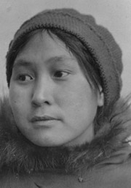
Ada Blackjack Johnson was born in Solomon, Alaska and raised by missionaries who taught her to read English Early in her life, Blackjack relocated to Nome, Alaska. She married and gave birth to three children with her first husband, but only one survived past infancy. She and the first husband divorced after that. The divorce left her destitute, and she temporarily placed her son in an orphanage. Soon after, in 1921, she joined an expedition across the Chukchi Sea to Russia's Wrangel Island led by Canadian Allan Crawford but financed, planned and encouraged by Vilhjalmur Stefansson.

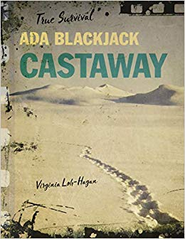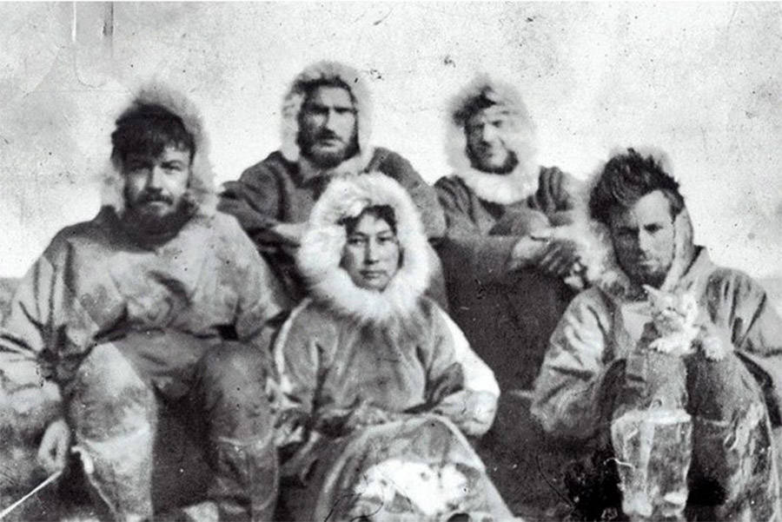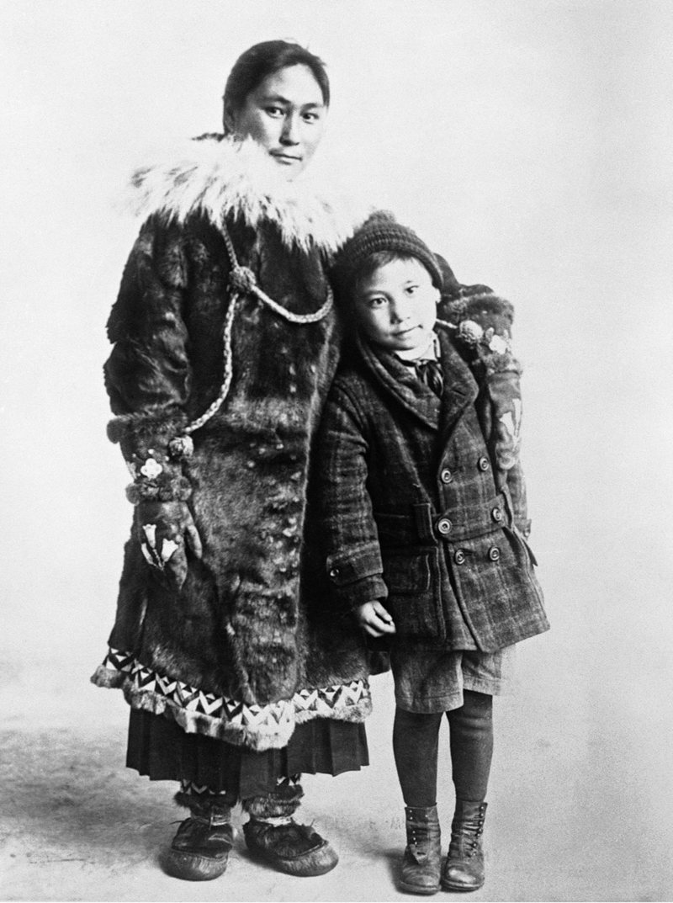

1. Story of Ada Blackjack
Setting – In the Arctic region, where Ada was born and brought up, and
Wrangel Island where she went with the explorers.
Main character – Ada Blackjack
Supporting characters - Lorne Knight, Milton Galle, Fred Maurer, Allan Crawford,
Vilhjalnmer Stefansson, Ada’s grandmother and Ada’s son Bennet
Crisis in the story – Lorne Knight falls sick and they get no news of any help. Their food supply had depleted and they were almost starving as winter set in. Leaving Ada with Lorne, the three other explorers went out in search of help never to return. Lorne dies and Ada is left all alone to survive the Arctic.
Resolution of the crisis – Ada learns how to hunt animals using a rifle. She kills animals and birds like ducks, foxes and seals. She survives the island and comes back to her family finally.

